Containment

Definition
# Source: AI Source: Provided by: [Data Path: Persons Table -> ID Column: 1, Name_En Column: Motasem Essam] -> From: [ChatGPT] on [7/25/2026]
Containment is a geometric relationship in which one geometric object lies entirely within another geometric object.
If every point of geometric object A also belongs to geometric object B, then A is contained in B.
Mathematically:
$$\boxed{A⊆B}$$
This means:
$$∀P, P∈A⇒P∈B$$
Containment can occur between points, lines, segments, rays, planes, regions, surfaces, and solids.
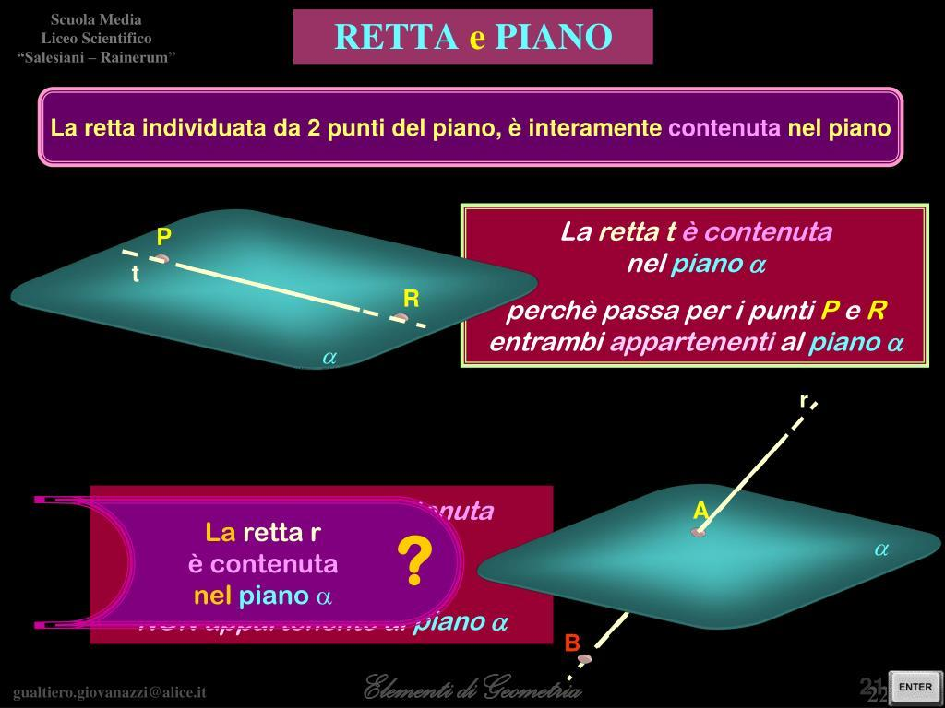
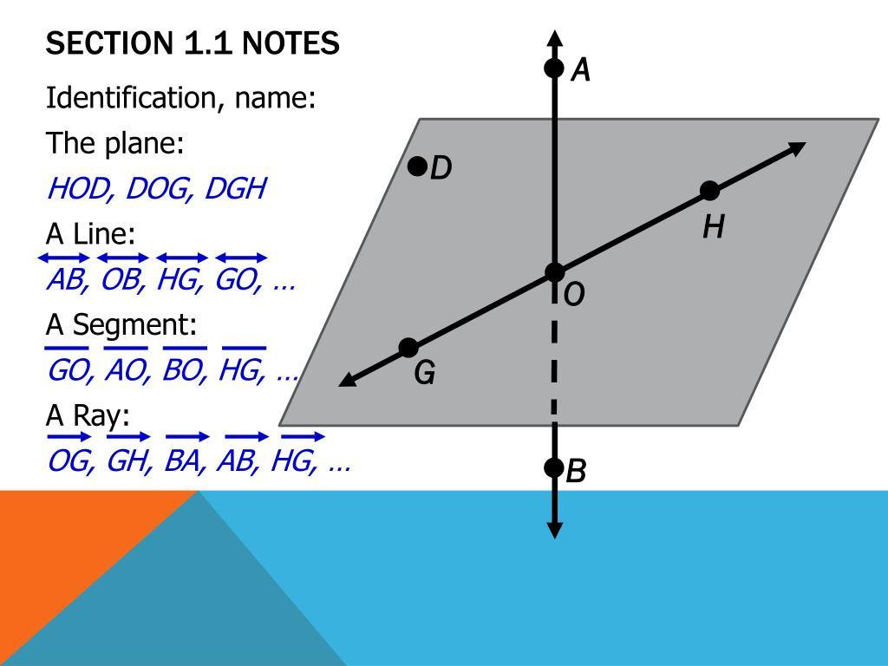
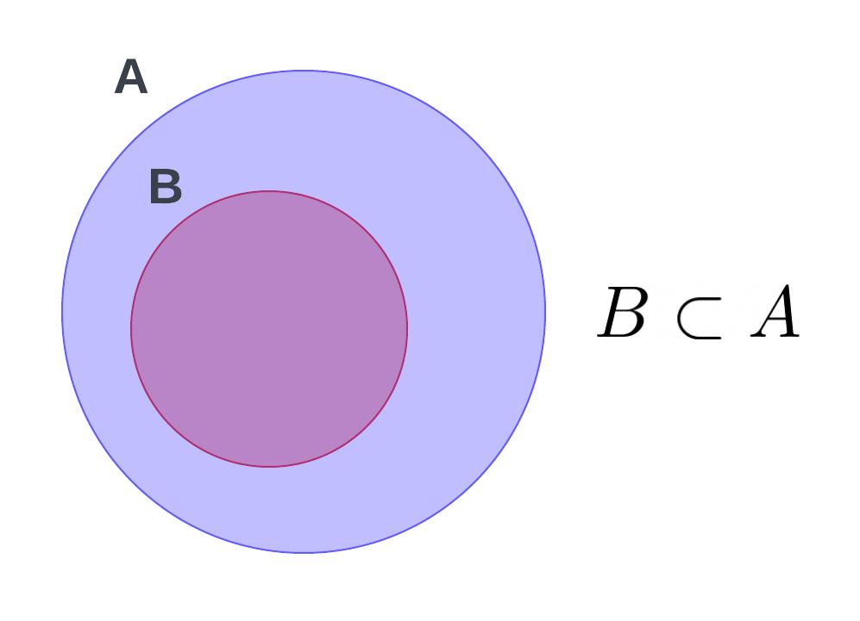
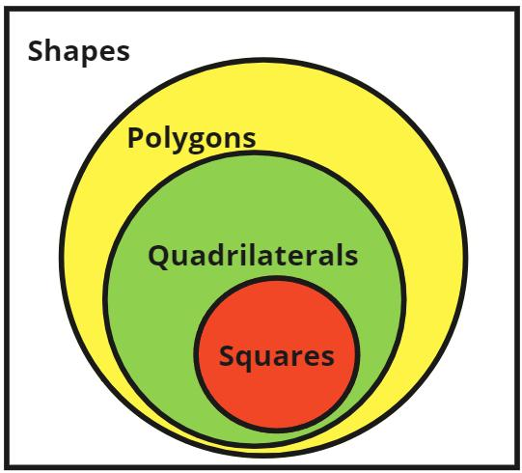

Purpose
# Source: AI Source: Provided by: [Data Path: Persons Table -> ID Column: 1, Name_En Column: Motasem Essam] -> From: [ChatGPT] on [7/25/2026]
Containment is used to:
- Describe when one geometric object lies inside another.
- Determine whether a point belongs to a line, segment, region, or solid.
- Describe relationships between lines and planes.
- Describe regions inside geometric figures.
- Analyze geometric sets using set theory.
- Establish whether an object is a subset of another geometric object.

Fundamental Concept
# Source: AI Source: Provided by: [Data Path: Persons Table -> ID Column: 1, Name_En Column: Motasem Essam] -> From: [ChatGPT] on [7/25/2026]
The central idea is:
$$\boxed{\text{Every point of the contained object belongs to the containing object.}}$$
For example, if a line segment \overline{AB} lies on a line l, then:
$$\boxed{\overset{‾}{AB}⊂l}$$
The segment is contained in the line because every point of the segment is also a point of the line.

Types of Geometric Containment
# Source: AI Source: Provided by: [Data Path: Persons Table -> ID Column: 1, Name_En Column: Motasem Essam] -> From: [ChatGPT] on [7/25/2026]
Containment can occur between different types of geometric objects.

1. Point Containment
# Source: AI Source: Provided by: [Data Path: Persons Table -> ID Column: 1, Name_En Column: Motasem Essam] -> From: [ChatGPT] on [7/25/2026]
A point is contained in a geometric object when the point lies on or inside that object.
For a point P on line l:
$$\boxed{P∈l}$$
For a point inside a circle's disk:
$$\boxed{P∈D}$$
where D represents the disk.
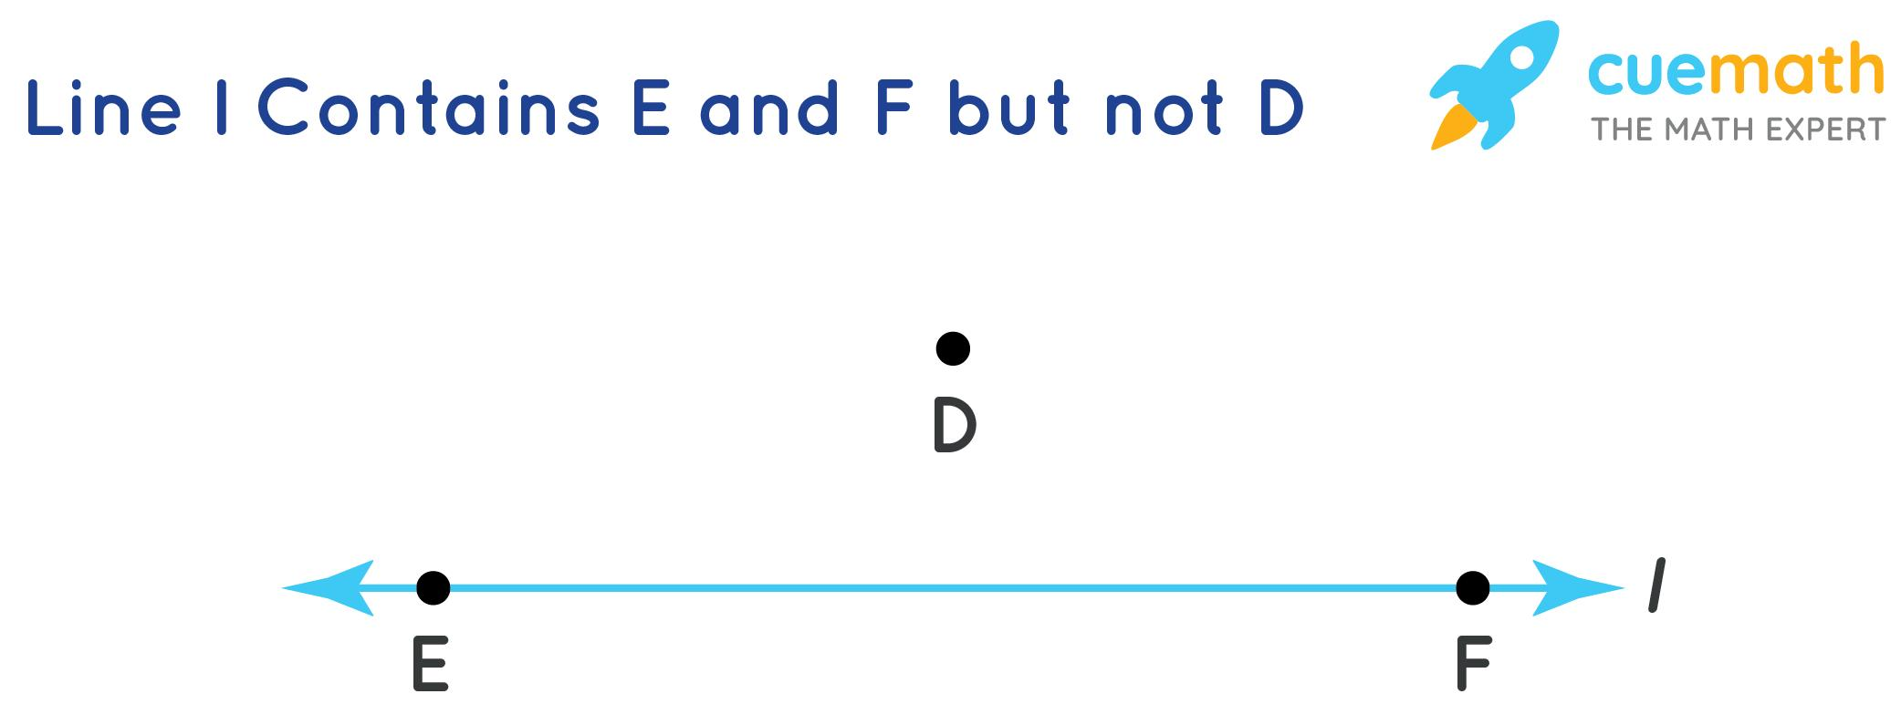
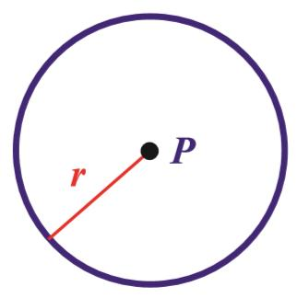
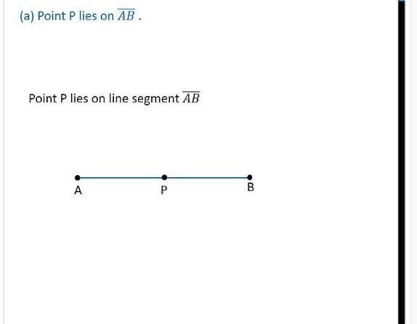
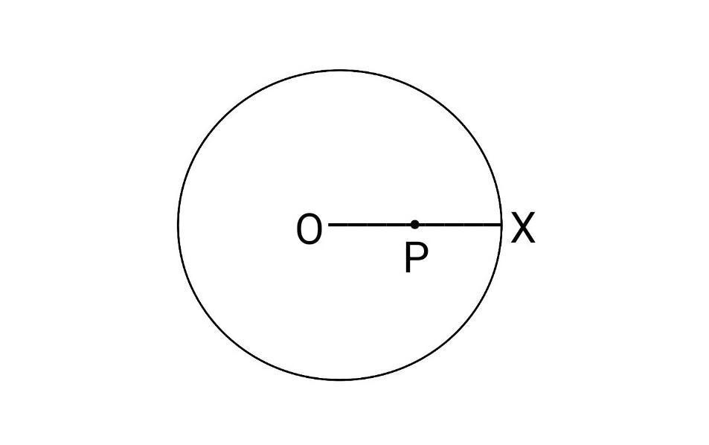
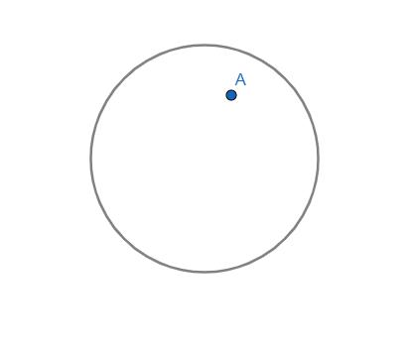

2. Segment Containment in a Line
# Source: AI Source: Provided by: [Data Path: Persons Table -> ID Column: 1, Name_En Column: Motasem Essam] -> From: [ChatGPT] on [7/25/2026]
A finite line segment can be contained in an infinite line.
If every point of \overline{AB} lies on line l:
$$\boxed{\overset{‾}{AB}⊂l}$$
The line extends infinitely in both directions, while the segment occupies only part of the line.

3. Ray Containment in a Line
# Source: AI Source: Provided by: [Data Path: Persons Table -> ID Column: 1, Name_En Column: Motasem Essam] -> From: [ChatGPT] on [7/25/2026]
A ray is also contained in its supporting line.
If ray \overrightarrow{AB} lies on line l:
$$\boxed{\vec{AB}⊂l}$$
The ray contains one endpoint and extends infinitely in one direction.

4. Line Containment in a Plane
# Source: AI Source: Provided by: [Data Path: Persons Table -> ID Column: 1, Name_En Column: Motasem Essam] -> From: [ChatGPT] on [7/25/2026]
A line can be contained entirely within a plane.
If every point of line l belongs to plane \Pi:
$$\boxed{l⊂Π}$$
This is one of the fundamental containment relationships in three-dimensional geometry.
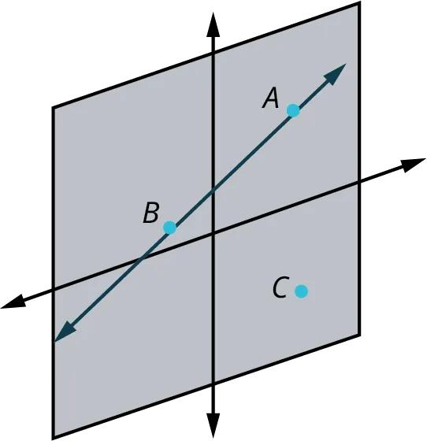
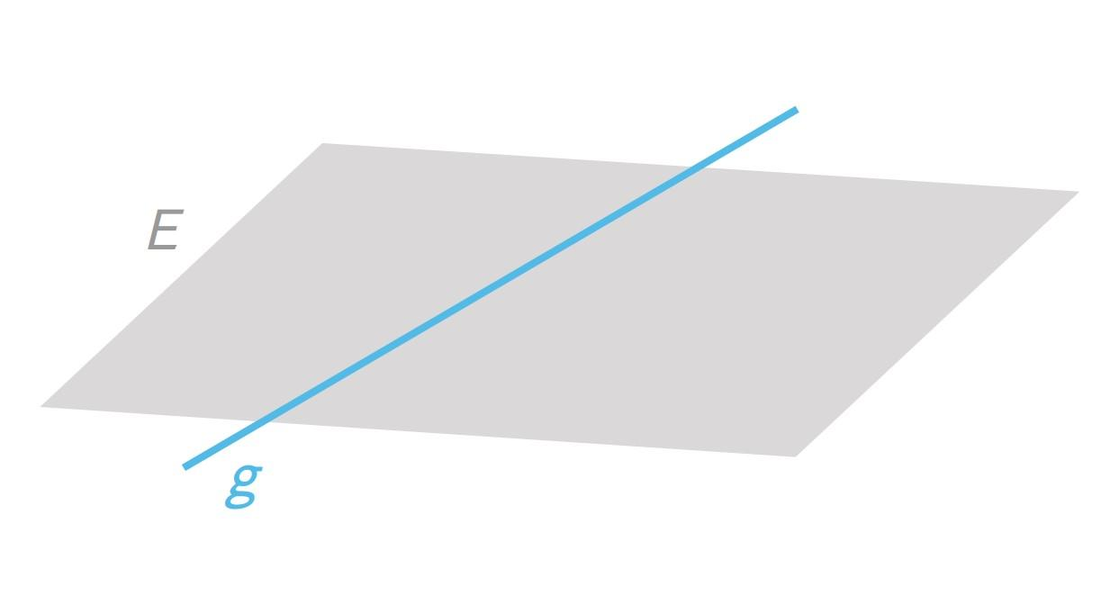
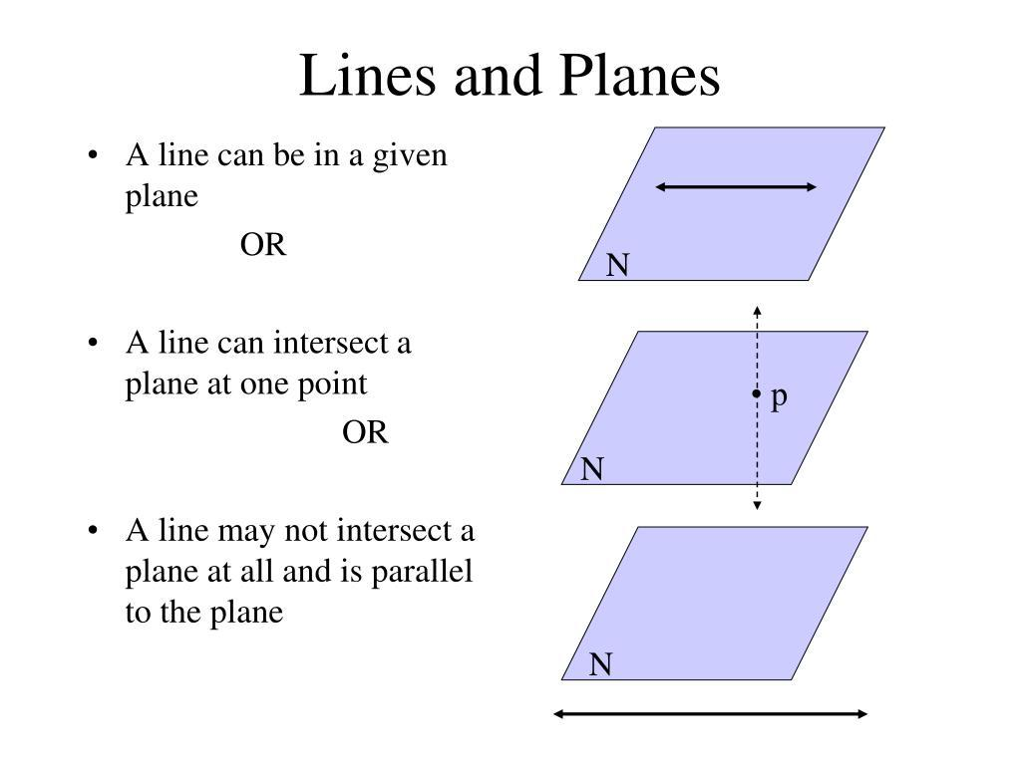

5. Segment Containment in a Plane
# Source: AI Source: Provided by: [Data Path: Persons Table -> ID Column: 1, Name_En Column: Motasem Essam] -> From: [ChatGPT] on [7/25/2026]
A line segment can also lie entirely within a plane:
$$\boxed{\overset{‾}{AB}⊂Π}$$
Because the segment is part of a line and the line lies in the plane, the entire segment lies in the plane.

6. Plane Containment in Space
# Source: AI Source: Provided by: [Data Path: Persons Table -> ID Column: 1, Name_En Column: Motasem Essam] -> From: [ChatGPT] on [7/25/2026]
A plane is contained in three-dimensional Euclidean space:
$$\boxed{Π⊂R^{3}}$$
Every point of the plane has three-dimensional coordinates.
For example:
$$Π: z=0$$
is the xy-coordinate plane, and:
$$Π⊂R^{3}$$

7. Region Containment
# Source: AI Source: Provided by: [Data Path: Persons Table -> ID Column: 1, Name_En Column: Motasem Essam] -> From: [ChatGPT] on [7/25/2026]
A geometric region can be contained inside another region.
For example, a smaller circle can lie completely inside a larger disk.
If D_1 is completely inside D_2:
$$\boxed{D_{1}⊆D_{2}}$$
If they have no common boundary points, then:
$$\boxed{D_{1}⊂D_{2}}$$
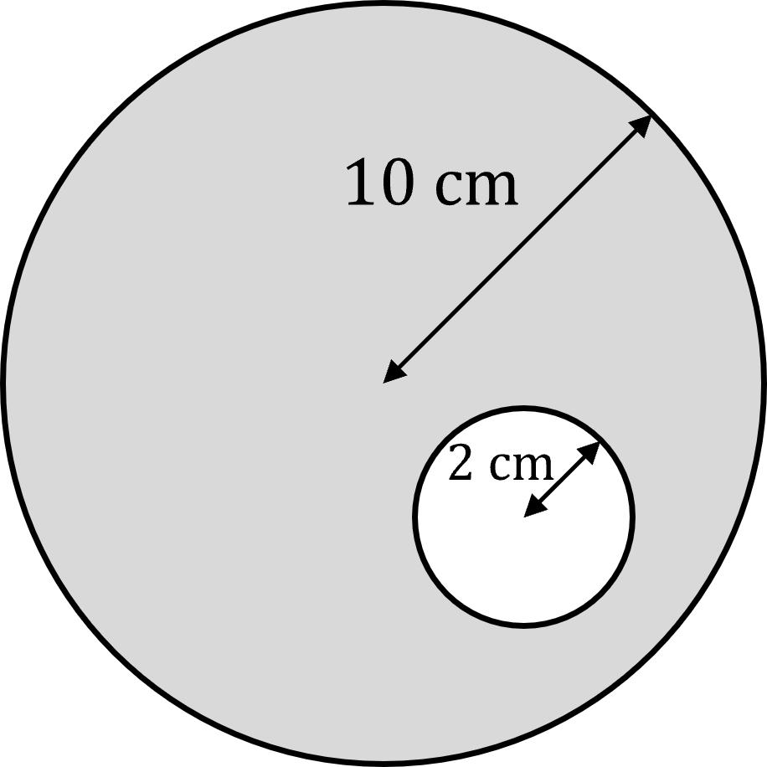
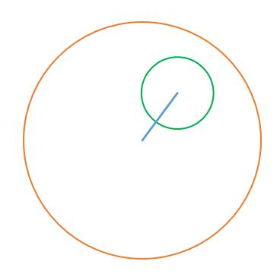
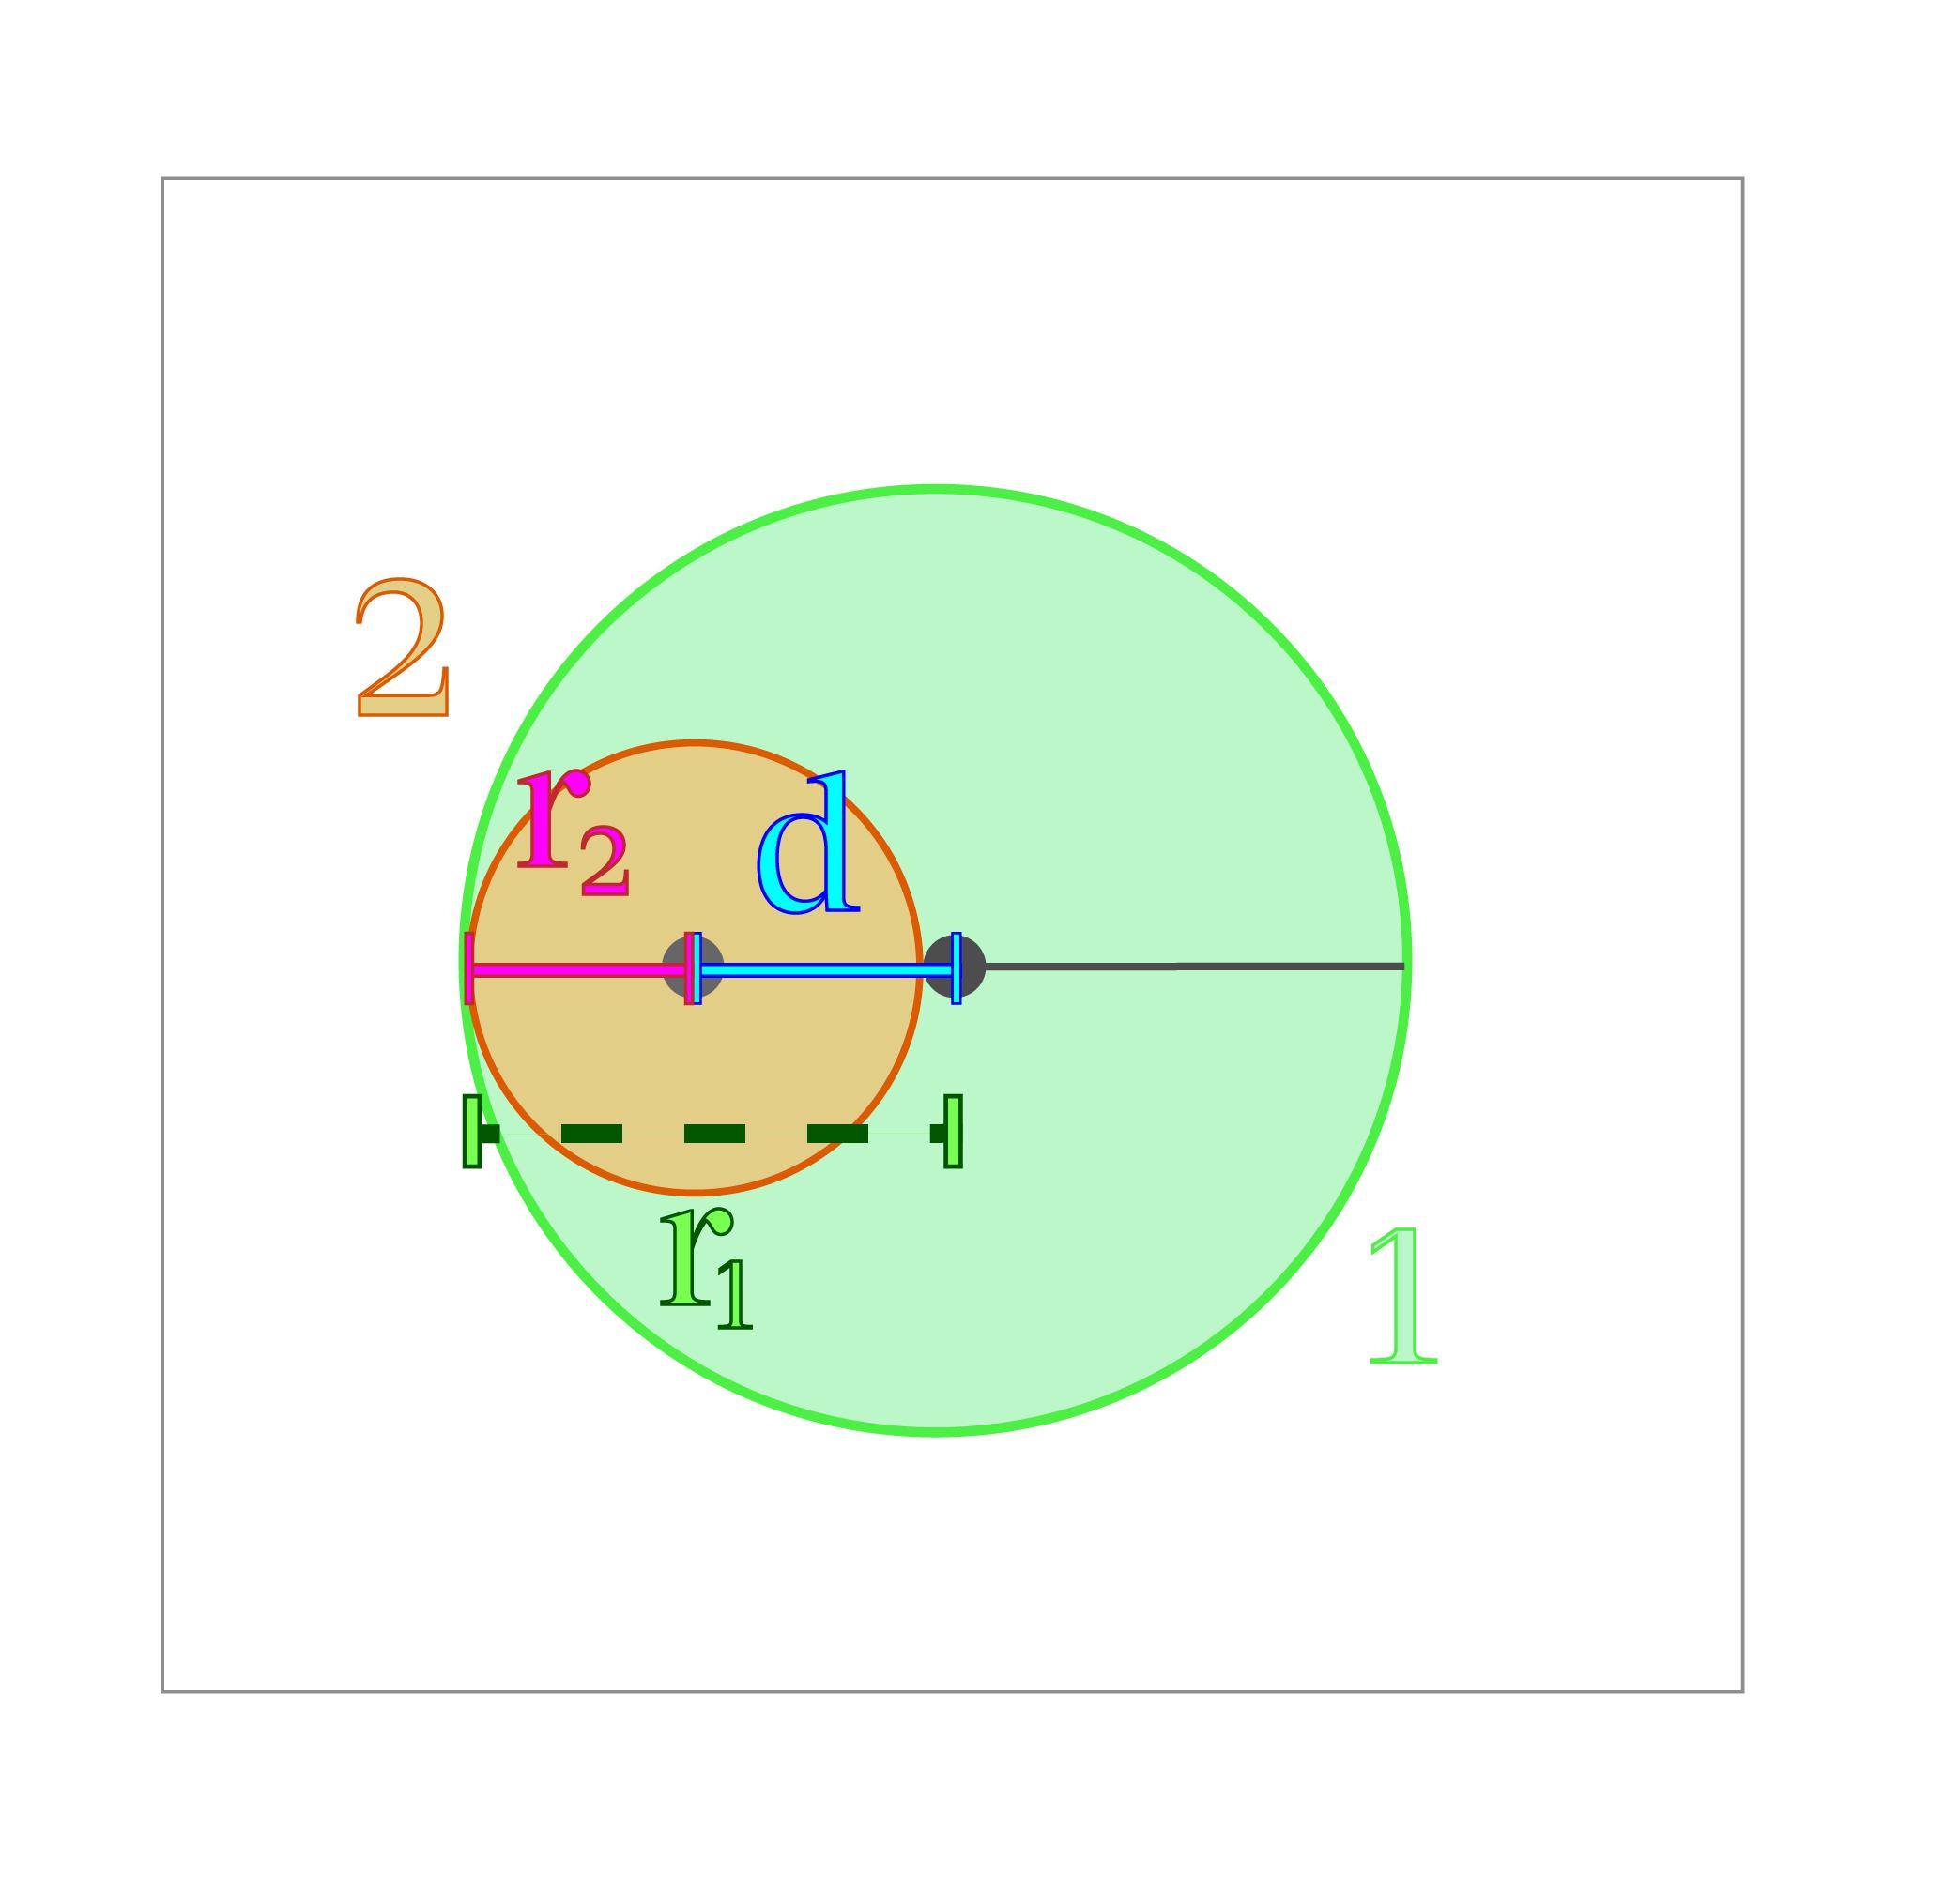

Mathematical Representation
# Source: AI Source: Provided by: [Data Path: Persons Table -> ID Column: 1, Name_En Column: Motasem Essam] -> From: [ChatGPT] on [7/25/2026]
Containment is fundamentally represented using set notation.
Subset
$$A⊆B$$
means every element of A is also an element of B.
Proper subset
$$A⊂B$$
means:
$$A⊆B$$
and:
$$A≠B$$
Therefore, A is completely contained within B but is not identical to it.
Equality
If two geometric objects contain exactly the same points:
$$\boxed{A=B}$$
This corresponds to coincidence, rather than proper containment.

Containment vs Coincidence
# Source: AI Source: Provided by: [Data Path: Persons Table -> ID Column: 1, Name_En Column: Motasem Essam] -> From: [ChatGPT] on [7/25/2026]
These concepts are closely related but different.
Suppose:
$$A⊆B$$
This only says that all points of A belong to B.
If:
$$A=B$$
then they occupy exactly the same geometric set.
Therefore:
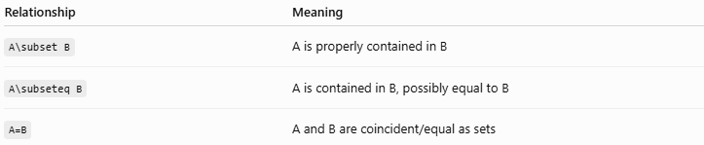
Relationship | Meaning
A\subset B | A is properly contained in B
A\subseteq B | A is contained in B, possibly equal to B
A=B | A and B are coincident/equal as sets
For example:
$$\overset{‾}{AB}⊂l$$
but:
$$\overset{‾}{AB}≠l$$
because the segment is finite while the line is infinite.

Containment vs Intersection
# Source: AI Source: Provided by: [Data Path: Persons Table -> ID Column: 1, Name_En Column: Motasem Essam] -> From: [ChatGPT] on [7/25/2026]
Containment is stronger than ordinary intersection.
If:
$$A⊆B$$
then:
$$A∩B=A$$
Therefore, the objects share all points of A.
By contrast, if:
$$A∩B≠∅$$
they may share only one point or a smaller portion.
Example:
- A line crossing a circle has an intersection.
- A line containing an entire line segment has containment.
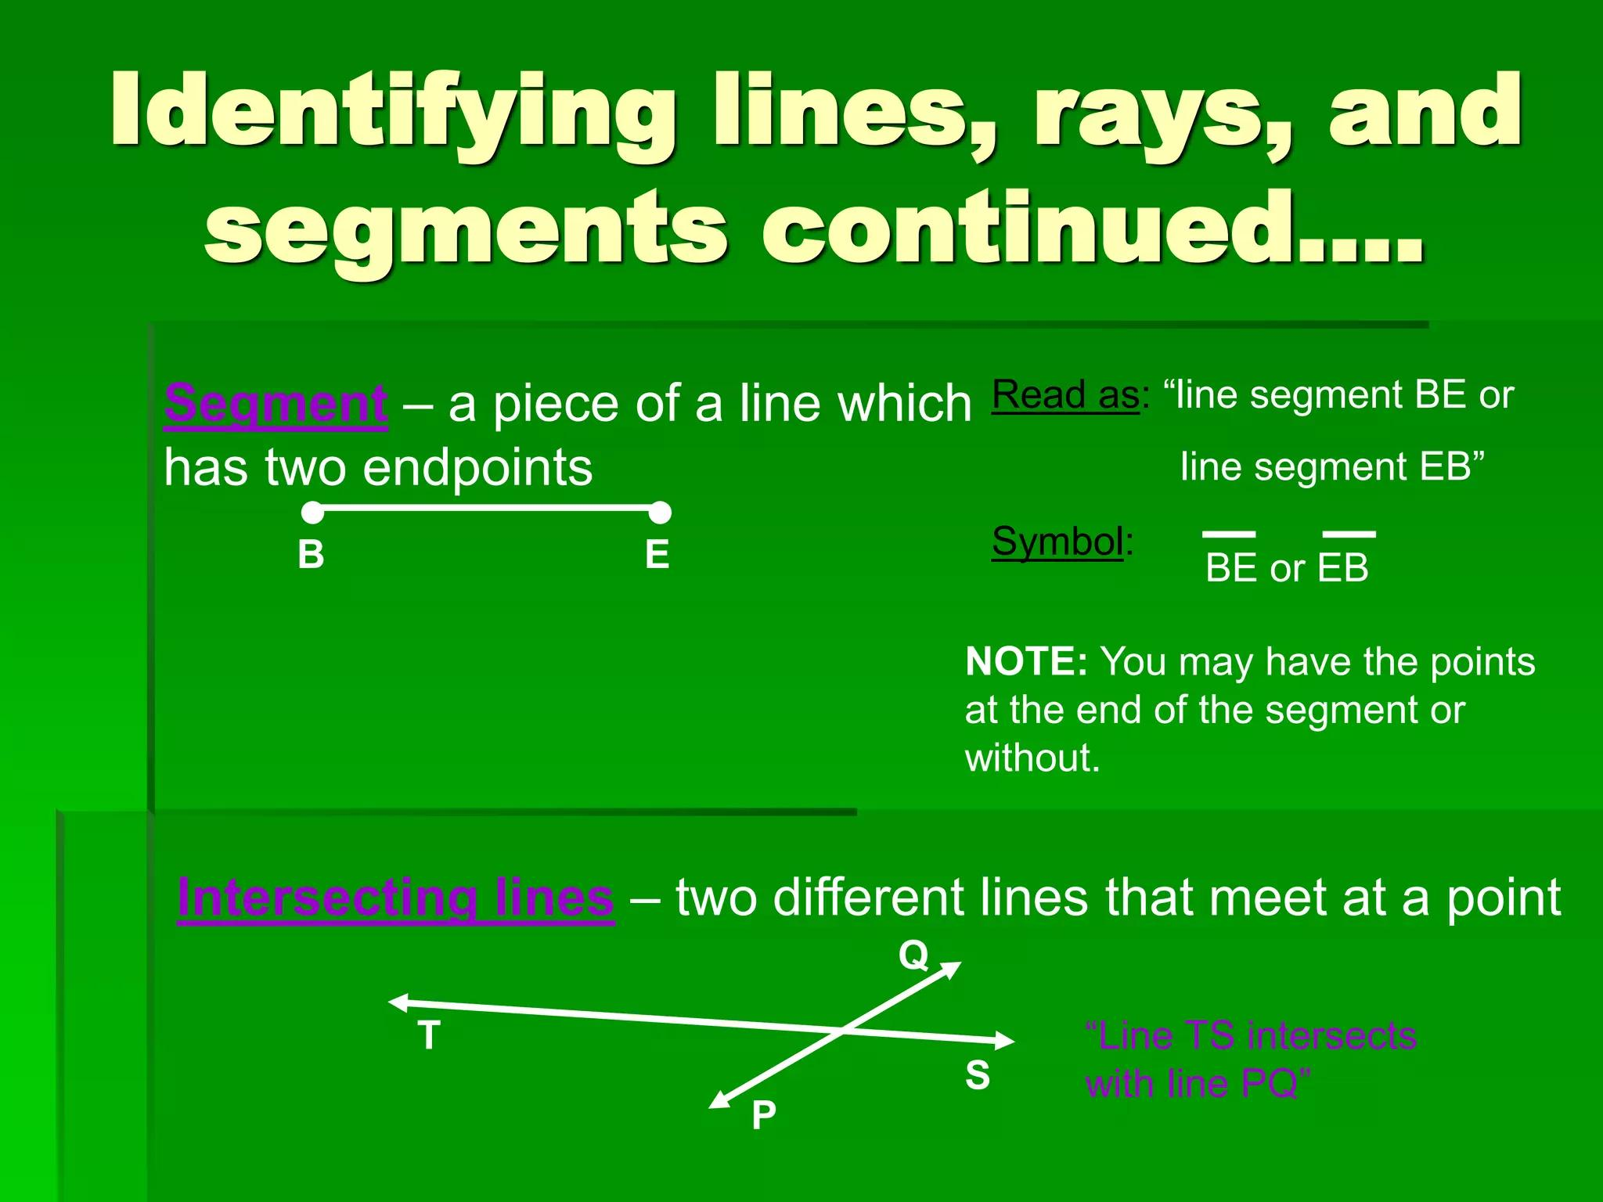
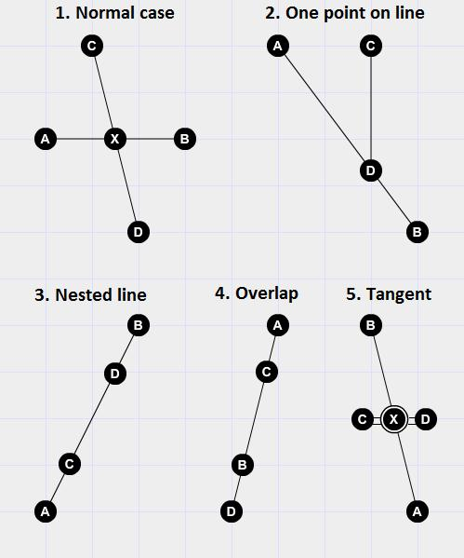
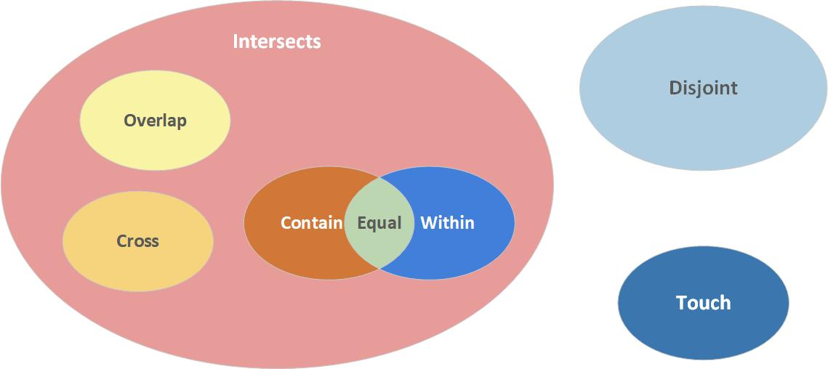

Containment in Coordinate Geometry
# Source: AI Source: Provided by: [Data Path: Persons Table -> ID Column: 1, Name_En Column: Motasem Essam] -> From: [ChatGPT] on [7/25/2026]
Containment can be tested using equations.
Consider the line:
$$l: y=2x+1$$
and the segment whose endpoints are:
$$A=\left(0 , 1\right)$$
and:
$$B=\left(2 , 5\right)$$
Both endpoints satisfy:
$$y=2x+1$$
and the entire segment between them lies on the line.
Therefore:
$$\boxed{\overset{‾}{AB}⊂l}$$

Containment of a Line in a Plane
# Source: AI Source: Provided by: [Data Path: Persons Table -> ID Column: 1, Name_En Column: Motasem Essam] -> From: [ChatGPT] on [7/25/2026]
Consider the plane:
$$Π: x+y+z=6$$
and the line:
$$\vec{r}=\left(\begin{matrix}1 \\ 2 \\ 3\end{matrix}\right)+t\left(\begin{matrix}1 \\ -1 \\ 0\end{matrix}\right)$$
Its coordinates are:
$$x=1+t \\ y=2-t \\ z=3$$
Substituting into the plane equation:
$$\left(1+t\right)+\left(2-t\right)+3=6 \\ 6=6$$
for every value of t.
Therefore, every point of the line belongs to the plane:
$$\boxed{l⊂Π}$$
Thus the line is contained in the plane.

Containment of a Circle in a Disk
# Source: AI Source: Provided by: [Data Path: Persons Table -> ID Column: 1, Name_En Column: Motasem Essam] -> From: [ChatGPT] on [7/25/2026]
Consider a disk centered at the origin with radius R:
$$D=\left\{\left(x , y\right):x^{2}+y^{2}≤R^{2}\right\}$$
Every point of its boundary circle satisfies:
$$x^{2}+y^{2}=R^{2}$$
Therefore, the circle is contained in the disk:
$$\boxed{C⊆D}$$
This is an important distinction between a circle as a boundary curve and a disk as the filled region.

Containment in 3D Geometry
# Source: AI Source: Provided by: [Data Path: Persons Table -> ID Column: 1, Name_En Column: Motasem Essam] -> From: [ChatGPT] on [7/25/2026]
Containment is especially important in spatial geometry.
Examples include:
$$\text{Point}⊂\text{Line} \\ \text{Line}⊂\text{Plane} \\ \text{Plane}⊂\text{Space}$$
and regions/surfaces contained within solids.
A useful hierarchy is:
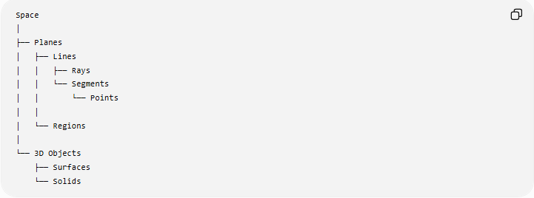
Space
│
├── Planes
│ ├── Lines
│ │ ├── Rays
│ │ └── Segments
│ │ └── Points
│ │
│ └── Regions
│
└── 3D Objects
├── Surfaces
└── Solids
This hierarchy illustrates many possible containment relationships, although it should not be interpreted as saying that every plane contains every line or every solid contains every surface.

Boundary Containment
# Source: AI Source: Provided by: [Data Path: Persons Table -> ID Column: 1, Name_En Column: Motasem Essam] -> From: [ChatGPT] on [7/25/2026]
An object can be contained in another object while touching its boundary.
For example, a smaller disk may touch the boundary of a larger disk at one point.
Then:
$$D_{1}⊆D_{2}$$
but:
$$∂D_{1}∩∂D_{2}≠∅$$
So containment does not necessarily mean that the contained object is completely separated from the boundary.

Strict Interior Containment
# Source: AI Source: Provided by: [Data Path: Persons Table -> ID Column: 1, Name_En Column: Motasem Essam] -> From: [ChatGPT] on [7/25/2026]
If an object lies completely inside another object and does not touch the containing object's boundary, it can be described as being contained in its interior.
For example:
$$D_{1}⊂int⁡\left(D_{2}\right)$$
This is stronger than ordinary containment.
Comparison
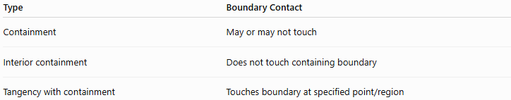
Type | Boundary Contact
Containment | May or may not touch
Interior containment | Does not touch containing boundary
Tangency with containment | Touches boundary at specified point/region

Main Properties
# Source: AI Source: Provided by: [Data Path: Persons Table -> ID Column: 1, Name_En Column: Motasem Essam] -> From: [ChatGPT] on [7/25/2026]
- Containment is fundamentally a set relationship.
- Every point of the contained object belongs to the containing object.
- It is represented by:
$$A⊆B$$
- Proper containment is represented by:
$$A⊂B$$
- If:
$$A=B$$
the objects are coincident rather than properly contained.
6. A segment can be contained in a line.
7. A line can be contained in a plane.
8. A plane can be contained in three-dimensional space.
9. A geometric region can be contained within another region.
10. Containment can occur in both 2D and 3D geometry.
11. Containment does not necessarily mean that the contained object is strictly away from the boundary.

Examples

Example 1 – Point in Segment
# Source: AI Source: Provided by: [Data Path: Persons Table -> ID Column: 1, Name_En Column: Motasem Essam] -> From: [ChatGPT] on [7/25/2026]
If:
$$A=\left(0 , 0\right), B=\left(4 , 0\right)$$
and:
$$P=\left(2 , 0\right)$$
then P lies on $\overset{‾}{AB}$:
$$\boxed{P∈\overset{‾}{AB}}$$

Example 2 – Segment in Line
# Source: AI Source: Provided by: [Data Path: Persons Table -> ID Column: 1, Name_En Column: Motasem Essam] -> From: [ChatGPT] on [7/25/2026]
If:
$$l:y=3x+2$$
and segment $\overset{‾}{AB}$ lies entirely on this line:
$$\boxed{\overset{‾}{AB}⊂l}$$

Example 3 – Line in Plane
# Source: AI Source: Provided by: [Data Path: Persons Table -> ID Column: 1, Name_En Column: Motasem Essam] -> From: [ChatGPT] on [7/25/2026]
If:
$$l⊂Π$$
then every point on l is also a point of \Pi.
Therefore:
$$\boxed{l⊂Π}$$

Example 4 – Circle in Disk
# Source: AI Source: Provided by: [Data Path: Persons Table -> ID Column: 1, Name_En Column: Motasem Essam] -> From: [ChatGPT] on [7/25/2026]
For:
$$C:x^{2}+y^{2}=25$$
and:
$$D:x^{2}+y^{2}≤25$$
we have:
$$\boxed{C⊆D}$$
The circle forms the boundary of the disk.

Relationship with Related Concepts
# Source: AI Source: Provided by: [Data Path: Persons Table -> ID Column: 1, Name_En Column: Motasem Essam] -> From: [ChatGPT] on [7/25/2026]
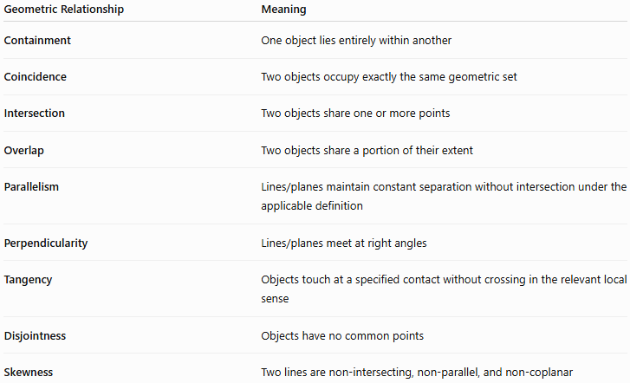
Geometric Relationship | Meaning
Containment | One object lies entirely within another
Coincidence | Two objects occupy exactly the same geometric set
Intersection | Two objects share one or more points
Overlap | Two objects share a portion of their extent
Parallelism | Lines/planes maintain constant separation without intersection under the applicable definition
Perpendicularity | Lines/planes meet at right angles
Tangency | Objects touch at a specified contact without crossing in the relevant local sense
Disjointness | Objects have no common points
Skewness | Two lines are non-intersecting, non-parallel, and non-coplanar

Containment vs Overlap
# Source: AI Source: Provided by: [Data Path: Persons Table -> ID Column: 1, Name_En Column: Motasem Essam] -> From: [ChatGPT] on [7/25/2026]
These should not be treated as identical.
Containment
$$A⊆B$$
means all of A is inside B.
Overlap
Two objects overlap when they share some portion, but neither necessarily contains the other.
For example:
$$A∩B≠∅$$
while:
$$A⊈B$$
and:
$$B⊈A$$
Thus:
$$\boxed{\text{Containment is a specific, stronger form of spatial inclusion.}}$$

Real-World Applications
# Source: AI Source: Provided by: [Data Path: Persons Table -> ID Column: 1, Name_En Column: Motasem Essam] -> From: [ChatGPT] on [7/25/2026]
Containment is useful in:
- Architecture – rooms contained within buildings.
- Engineering – components positioned inside larger structures.
- Computer graphics – objects contained within bounding boxes.
- CAD – determining whether geometric features lie within regions.
- Geographic information systems (GIS) – determining whether one region lies inside another.
- Robotics – checking whether a robot or component lies within an operating region.
- Manufacturing – verifying that components fit inside specified boundaries.
- Physics – describing particles or fields within spatial regions.

Advantages
# Source: AI Source: Provided by: [Data Path: Persons Table -> ID Column: 1, Name_En Column: Motasem Essam] -> From: [ChatGPT] on [7/25/2026]
- Provides a precise mathematical description of inclusion.
- Works naturally with set theory and coordinate geometry.
- Useful in both 2D and 3D geometry.
- Helps establish hierarchical relationships between geometric objects.
- Makes geometric membership and inclusion precise.
- Useful for computational geometry and CAD.

Limitations
# Source: AI Source: Provided by: [Data Path: Persons Table -> ID Column: 1, Name_En Column: Motasem Essam] -> From: [ChatGPT] on [7/25/2026]
- Containment depends on the exact geometric objects being considered.
- A visual diagram alone may not prove containment.
- Boundary conventions can matter, especially for regions and solids.
- ⊆ allows equality, while ⊂ is commonly used for proper containment, but notation conventions can vary between mathematical texts.
- Containment is different from simply being visually "inside" an object; the mathematical set of points must satisfy the relationship.

Key Points
# Source: AI Source: Provided by: [Data Path: Persons Table -> ID Column: 1, Name_En Column: Motasem Essam] -> From: [ChatGPT] on [7/25/2026]
- Containment means that one geometric object lies entirely within another.
- Its fundamental mathematical representation is:
$$\boxed{A⊆B}$$
- Proper containment is:
$$\boxed{A⊂B}$$
- Coincidence is:
$$\boxed{A=B}$$
- A point can be contained in a line, segment, region, or surface.
- A segment or ray can be contained in a line.
- A line can be contained in a plane.
- A plane can be contained in \mathbb{R}^3.
- A circle can be contained in a disk.
- Containment may include boundary contact.
- Containment is stronger than ordinary intersection.
- It belongs under:
$$\boxed{\text{Geometric Relationships}→\text{Positional Relationships}}$$

Conclusion
# Source: AI Source: Provided by: [Data Path: Persons Table -> ID Column: 1, Name_En Column: Motasem Essam] -> From: [ChatGPT] on [7/25/2026]
Containment describes the complete inclusion of one geometric object within another. It is fundamentally a set-theoretic relationship, expressed by A\subseteq B, meaning that every point of A is also a point of B. It applies broadly across geometry, from a point contained in a segment to a line contained in a plane and a region contained in a larger region. In your geometric-relationship taxonomy, Containment should be a distinct positional relationship, not a subtype of Intersection, because it describes complete inclusion rather than merely shared points.
Would you like the next topic to be overlap or disjointness?

